**Angular Routing- Students Handout**

**Workshop 1**

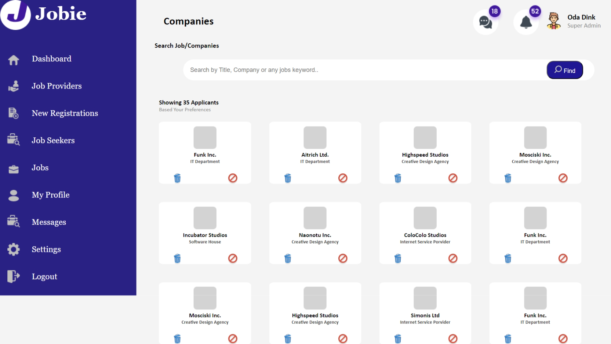

* Add routing to New Registrations and show the page like SPA.

**Expected Output**

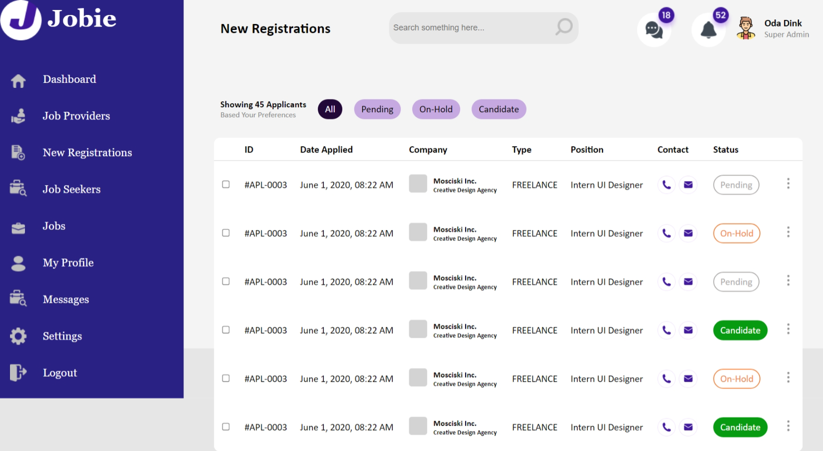

**Workshop-2**

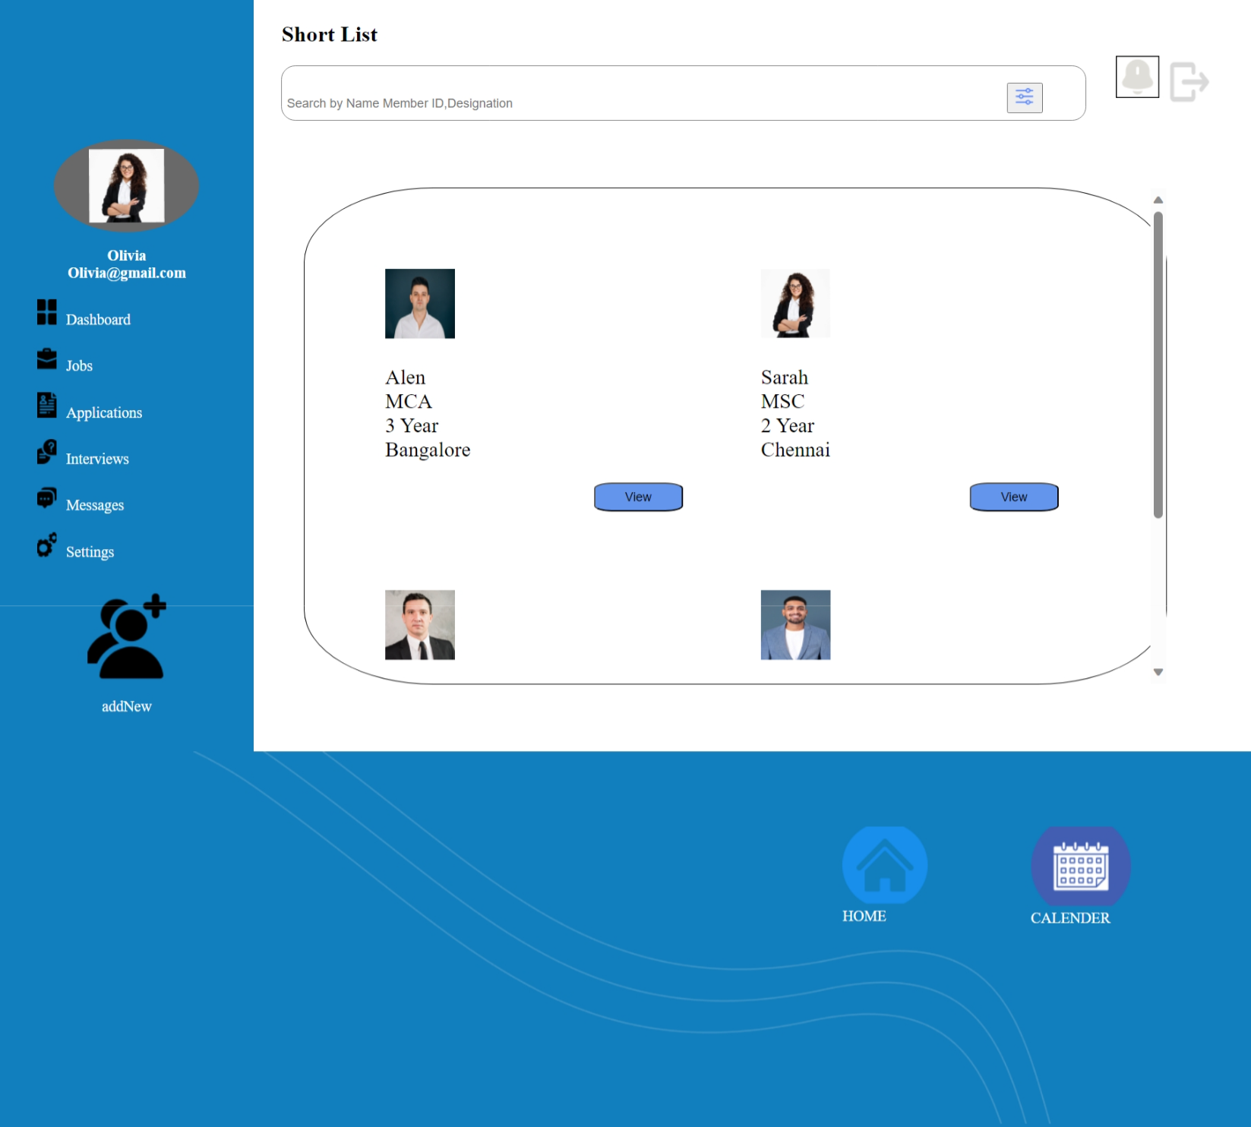

* Add routing to Jobs and show the page like SPA.

**Expected Output**



**Workshop 3**

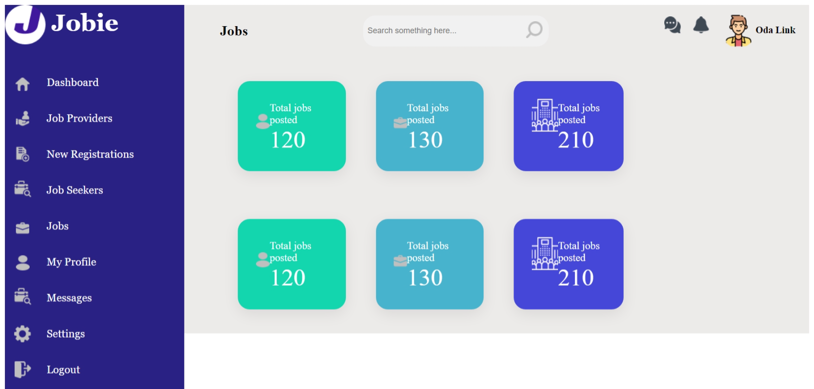

* Add routing to Jobs and show the page like SPA.

**Expected Output**

